Lesson 3
Solutions of Right Triangle

sPECIFIC OBJECTIVES:
At the end of the lesson, the student is expected to:
- Solve right triangles given the measures of one angle and one side or the measures of two sides.
- Define angles of elevation and depression.
- Define course and bearing.
- Solve application problems on right triangles.

2.1 Solution of Right Triangle

Solving a triangle means determining the measures of all sides and angles of the triangles. In solving problems involving right triangle, the following steps may be considered:
- Sketch the required triangle as accurate as possible based on the given data.
- Identify the given and the required parts of the triangle.
- Solve for the unknown parts of the triangle using any of the following:
- The definitions of the trigonometric functions.
- The Pythagorean relations
- The relation of complementary angles.

Remark:

When solving right triangles for the missing sides or angles, try to use only information in the problem rather values that are calculated.

Example 2.1 Solve the following triangles, in which C = 90°:

a) a = 35 , c = 92
- A = 29°30’ , b = 72.8
- B = 17°24’ , b = 45.5

Exercise 2.1.1 Solve each triangle ABC, where C = 90°

2. B

_{52.25°}
C A
^{35.9m}
1. B

_{46°20’}
⁶⁴⁹ a

A C
^{b}

B

_{42.92}

c

_{58.61}

A

3.

4. B = 36°28’, a = 29.4

5. A = 42°12’ , c = 31.26

Exercise 2.1.2

A. Solve for all missing parts of the right triangle ABC where C = 90°:

  - a = 19 cm , B = 42°
  - a = 30 ft., b = 19 ft.
  - c = 79.63 cm, A = 32° 53’
  - b = 1.379 km., A = 49° 36’ 28”
  - B = 24.71°, c = 2352.4 cm

- Compute for the length of AD
A
B

8 cm

48°

C
72°10’

D

- Compute for the missing parts of the given composite triangle.
B
16cm
A
63°
C

φ
70°
28°
D
θ
E

D. Solve for LM.
52° 25’
25° 30’
48
L
N
M
K

2.2 Angles of Elevation and Depression
Definition 2.2 Angles of Elevation and Depression

If an observer sights an object, the angle formed between a horizontal line and his line of sight is called the angle of elevation if the line of sight is above the horizontal and the angle of depression if the line of sight is below the horizontal.

B (Object)

θ angle of elevation
A
Horizontal Line

Horizontal Line
A
θ angle of depression

B (Object)

Example 2.2.1 If the angle of elevation of the top of the tower is 52°31’. Find the
height of th tower if the observer is 41.5 m from its base.

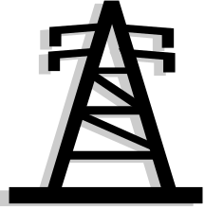
H

52°31’

41.5

Ans. 54.12 m

Example 2.2.2 Find the angle of elevation of the sun if the shadow of the pole 60 ft tall reaches 92 ft from the pole.

60 ft

.

θ
92 ft.

Ans. 33°06’41”

Example 2.2.3 From the top of a lighthouse 30 m high, the angle of depression of a boat in the sea was 28°45’. How far was the boat from the top and base of lighthouse?

28°45’

30m

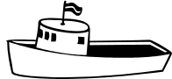
28°45’
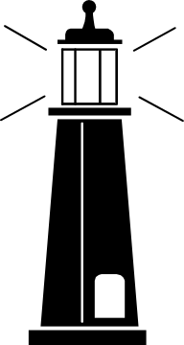

Ans. 54.68 m and

62.37 m

Example 2.2.4 From a window Carlo observes the lamp post. He noted that the angle of elevation of its top is 43°20’ while the angle of depression of its base is 20°15’. If the top of the lamp post is 30 m away from the window and its base is 25 m, what is the height of the lamp post?

30m
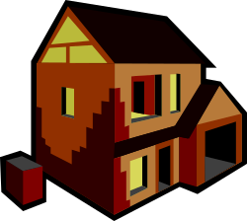
A
43° 20’

20°15’

25m

Ans. 29.24 m

Example 2.2.5 From where he stands 75 ft. away from the tree, a mountaineer 6 ft. tall, found that the angle of elevation of the top of the tree was 37°25’. Find the total height of the tree?



37° 25’


6 ft.

75 ft.

2.3 Direction of Angles
There are two ways in which the direction of an angle can be determined. They are bearing and course.

Definition 2.3.1 Bearing

Bearing of the point is the clockwise angle from north to the line of sight to appoint of reference.

Definition: 2.3.2 Course
In air or sea navigation, the angle measured clockwise from north to the line of travel is the course of the plane or the ship.

Course of 75°, 150° and 315° are illustrated below.

N75°E S30°E N45°W

N
150°
S
N
S
N

75°
315°

S

Example 2.3.1 Towers A and B are on east-west line 125 m apart. Jojo, on the north of that line finds that the direction of towers A and B are N39°27’E and N50°33 W , respectively. How far is Jojo from each tower?

39°27’
50°33’
θ 50°33’ 39° 27’β

Tower A 125 Tower B
Ans. 79.43 m and 96.52 m

Example 2.3.2 From port Ilocandia to Camp Airstrip a plane flies on a course of 285°. If Camp Airstrip is 1525 km further north than Port Ilocandia, find the distance from Port Ilocandia to Camp Airstrip.

A

P
285°

Exercise 2.3 Show the complete solutions of the following problems:

- The shadow of a flagpole on horizontal ground is 10.5 meters when the angle of elevation of the sun is 33°25’. How tall is the flagpole?

- A surveyor on top of a 70 m building, finds that the angle of the depression of the marker is 47°30’. How far is the marker from the base of the building?

- The angle of elevation of the top of the tower is found to be 42° at point A and 52° at point B, 28 ft. nearer the tower. What is the height of the tower if both observation points and the base of the tower are in the same horizontal plane?

- Pepe and Pilar are 105 m apart are on the same horizontal ground. Pepe sees that a kite is directly over the head of Pilar and its angle of elevation is 67°20’. How high is the kite? How far is the kite from where Pepe stands?

- From a cliff 1500 m high, the two lighthouses in opposite directions have angles of depression of 32°9’ and 28°46’ , respectively. Find the distance between the two lighthouses.

- A car travels 125 km on a bearing of 38°15’ then make a turn on a bearing of 315 km. Find the distance from the starting point to the end of the trip.

